# Extracting Data and Creating Dataset for QT Dashboards Creation

The purpose of this document is to provide the details on the dashboard for funnel metrics.

*Scenarios:*

* QT Overview
* QT Funnel

*Event Used:*

* edgeflyoutstatusevent
* edgereceiptsubmitevent

Datasets:  
  
QT Overview:

1. Activation
2. DAUByMessage
3. DAUByDomainUpdated
4. DAUUpdated

QT Funnel:

1. SearchTransaction
2. PDPTransaction
3. OrganicTransaction

Metrics:  
  
Activation

1. timestamp
2. Domain
3. Count

Scope Script:



Dashboard Charts:

*Dashboard daily view*

Dashboard Link – [EdgeShoppingQTOverview (azure.com)](https://dataexplorer.azure.com/dashboards/02d3cf8d-6a7c-499d-b347-104c779c5e8e?p-_startTime=365days&p-_endTime=now#81e6ab81-0ebe-4d4c-bc55-e97b710bfdaa)

Dashboard Link – [EdgeShoppingQTDomainFilter (azure.com)](https://dataexplorer.azure.com/dashboards/02d3cf8d-6a7c-499d-b347-104c779c5e8e?p-_startTime=90days&p-_endTime=now&p-_domain=v-amazon.com#2651fd8b-467a-4857-b091-b519d31677e9)  
  
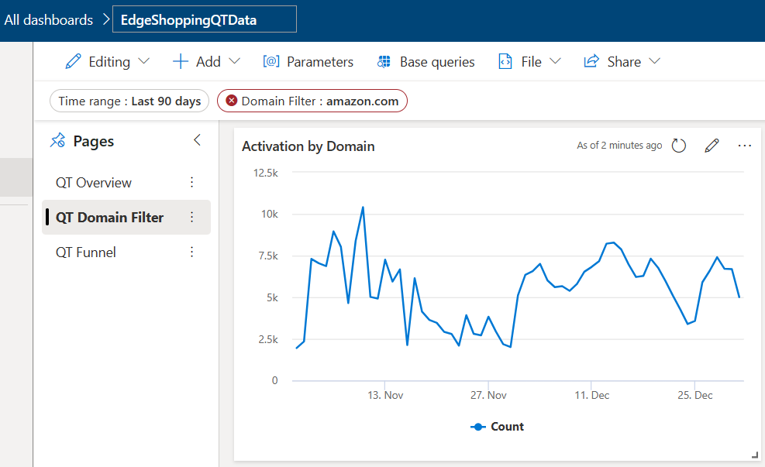  
  
File Location:

Cosmos path shared location:

*Cluster: cosmos08-prod-co3c*

*Virtual Cluster: ugc-prod*

*Dataset: Activation*Path: [cosmos08 ugc-prod cosmos/ugc-prod/local/Cashback/Metrics/EdgeShoppingQTScenario/QT-Overview/Activation/TSV/2023/11/ (osdinfra.net)](https://www.cosmos08.osdinfra.net/cosmos/ugc-prod/local/Cashback/Metrics/EdgeShoppingQTScenario/QT-Overview/Activation/TSV/2023/11/)

*Path Structure*:

**Structure:** Local / Cashback / Metrics / <ScenarioName> / <Sub Scenario Name> / <DatasetName> / <File Format> / <Year> / <Month> / FileName_YYYY_MM_DD.tsv  
  
**Example:** Local/ Cashback / Metrics / EdgeShoppingQTScenario/ QT-Overview / Activation / TSV / 2023 / 11 / activation_2023_11_01.tsv  
  
**Safety:** Local/ Cashback / Metrics / EdgeShoppingQTScenario / QT-Overview / Activation / TSV / 2023 / 11 / latest.tsv

DAUByMessage

1. timestamp
2. Message
3. Total
4. ManualTriggerViewed

Scope Script:



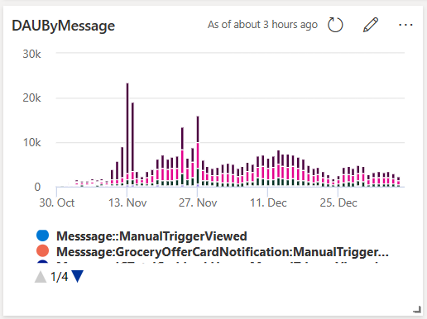

File Location:

Cosmos path shared location:

*Cluster: cosmos08-prod-co3c*

*Virtual Cluster: ugc-prod*

*Dataset: DAUByMessage*Path: [cosmos08 ugc-prod cosmos/ugc-prod/local/Cashback/Metrics/EdgeShoppingQTScenario/QT-Overview/DAUByMessage/TSV/2023/11/ (osdinfra.net)](https://www.cosmos08.osdinfra.net/cosmos/ugc-prod/local/Cashback/Metrics/EdgeShoppingQTScenario/QT-Overview/DAUByMessage/TSV/2023/11/)

*Path Structure*:

**Structure:** Local / Cashback / Metrics / <ScenarioName> / <Sub Scenario Name> / <DatasetName> / <File Format> / <Year> / <Month> / FileName_YYYY_MM_DD.tsv  
  
**Example:** Local/ Cashback / Metrics / EdgeShoppingQTScenario/ QT-Overview / DAUByMessage / TSV / 2023 / 11 / daubymessage_2023_11_01.tsv  
  
**Safety:** Local/ Cashback / Metrics / EdgeShoppingQTScenario / QT-Overview / DAUByMessage / TSV / 2023 / 11 / latest.tsv

DAUByDomainUpdated

Metric

1. timestamp
2. Domain
3. Total

Scope Script:



File Location:

Cosmos path shared location:

*Cluster: cosmos08-prod-co3c*

*Virtual Cluster: ugc-prod*

*Dataset: DAUByDomainUpdated*Path: [cosmos08 ugc-prod cosmos/ugc-prod/local/Cashback/Metrics/EdgeShoppingQTScenario/QT-Overview/DAUByDomainUpdated/TSV/2023/11/ (osdinfra.net)](https://www.cosmos08.osdinfra.net/cosmos/ugc-prod/local/Cashback/Metrics/EdgeShoppingQTScenario/QT-Overview/DAUByDomainUpdated/TSV/2023/11/)

*Path Structure*:

**Structure:** Local / Cashback / Metrics / <ScenarioName> / <Sub Scenario Name> / <DatasetName> / <File Format> / <Year> / <Month> / FileName_YYYY_MM_DD.tsv  
  
**Example:** Local/ Cashback / Metrics / EdgeShoppingQTScenario/ QT-Overview / DAUByDomainUpdated / TSV / 2023 / 11 / daubydomainupdated_2023_11_01.tsv  
  
**Safety:** Local/ Cashback / Metrics / EdgeShoppingQTScenario / QT-Overview / DAUByDomainUpdated / TSV / 2023 / 11 / latest.tsv

DAUUpdated

Metric

1. timestamp
2. Total
3. ManualTriggerViewed
4. SearchAutoShowEngaged
5. PDPAutoShowEngaged
6. GroceriesAutoShowEngaged
7. SPBEngaged

Scope Script:



File Location:

Cosmos path shared location:

*Cluster: cosmos08-prod-co3c*

*Virtual Cluster: ugc-prod*

*Dataset: DAUUpdated*Path: [cosmos08 ugc-prod cosmos/ugc-prod/local/Cashback/Metrics/EdgeShoppingQTScenario/QT-Overview/DAUUpdated/TSV/2023/11/ (osdinfra.net)](https://www.cosmos08.osdinfra.net/cosmos/ugc-prod/local/Cashback/Metrics/EdgeShoppingQTScenario/QT-Overview/DAUUpdated/TSV/2023/11/)

*Path Structure*:

**Structure:** Local / Cashback / Metrics / <ScenarioName> / <Sub Scenario Name> / <DatasetName> / <File Format> / <Year> / <Month> / FileName_YYYY_MM_DD.tsv  
  
**Example:** Local/ Cashback / Metrics / EdgeShoppingQTScenario/ QT-Overview / DAUUpdated / TSV / 2023 / 11 / dauupdated_2023_11_01.tsv  
  
**Safety:** Local/ Cashback / Metrics / EdgeShoppingQTScenario / QT-Overview / DAUUpdated / TSV / 2023 / 11 / latest.tsv

SearchTransaction

Metric

1. timestamp
2. ShownFlyout
3. HoveredFlyout
4. ActivatedOffer
5. PurchasedOffer

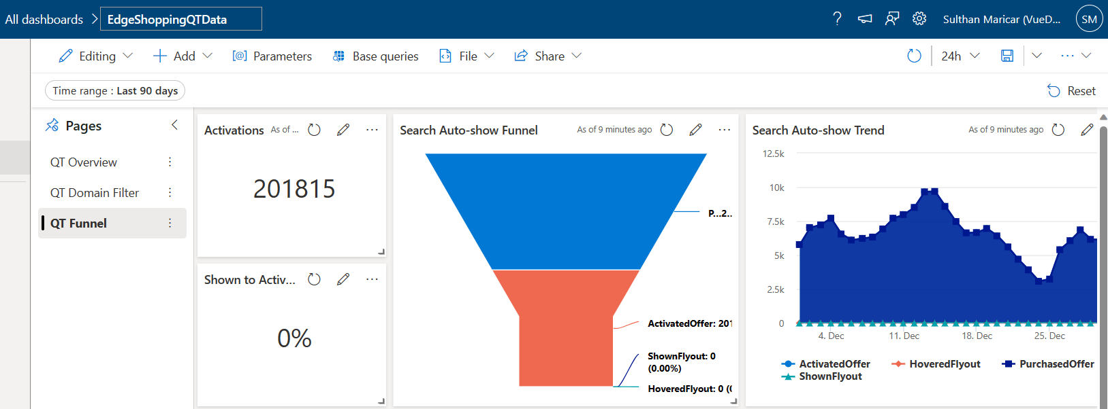  
  
Scope Script:



File Location:

Cosmos path shared location:

*Cluster: cosmos08-prod-co3c*

*Virtual Cluster: ugc-prod*

*Dataset: SearchTransaction*Path: [cosmos08 ugc-prod cosmos/ugc-prod/local/Cashback/Metrics/EdgeShoppingQTScenario/QT-Funnel/SearchTransaction/TSV/2023/11/ (osdinfra.net)](https://www.cosmos08.osdinfra.net/cosmos/ugc-prod/local/Cashback/Metrics/EdgeShoppingQTScenario/QT-Funnel/SearchTransaction/TSV/2023/11/)

*Path Structure*:

**Structure:** Local / Cashback / Metrics / <ScenarioName> / <Sub Scenario Name> / <DatasetName> / <File Format> / <Year> / <Month> / FileName_YYYY_MM_DD.tsv  
  
**Example:** Local/ Cashback / Metrics / EdgeShoppingQTScenario/ QT-Overview / SearchTransaction / TSV / 2023 / 11 / searchtransaction_2023_11_01.tsv  
  
**Safety:** Local/ Cashback / Metrics / EdgeShoppingQTScenario / QT-Overview / SearchTransaction / TSV / 2023 / 11 / latest.tsv  
  
  
Organic Transaction:

Metric

1. timestamp
2. ViewedFlyout
3. HoveredFlyout
4. ActivatedOffer
5. PurchasedOffer

Scope Script:



File Location:

Cosmos path shared location:

*Cluster: cosmos08-prod-co3c*

*Virtual Cluster: ugc-prod*

*Dataset: OrganicTransaction*Path: [cosmos08 ugc-prod cosmos/ugc-prod/local/Cashback/Metrics/EdgeShoppingQTScenario/QT-Funnel/OrganicTransaction/TSV/2023/12/ (osdinfra.net)](https://www.cosmos08.osdinfra.net/cosmos/ugc-prod/local/Cashback/Metrics/EdgeShoppingQTScenario/QT-Funnel/OrganicTransaction/TSV/2023/12/)

*Path Structure*:

**Structure:** Local / Cashback / Metrics / <ScenarioName> / <Sub Scenario Name> / <DatasetName> / <File Format> / <Year> / <Month> / FileName_YYYY_MM_DD.tsv  
  
**Example:** Local/ Cashback / Metrics / EdgeShoppingQTScenario/ QT-Overview / OrganicTransaction / TSV / 2023 / 11 / searchtransaction_2023_11_01.tsv  
  
**Safety:** Local/ Cashback / Metrics / EdgeShoppingQTScenario / QT-Overview / OrganicTransaction / TSV / 2023 / 11 / latest.tsv  
  
  
PDP Transaction:

Metric:

1. timestamp
2. ViewedFlyout
3. HoveredFlyout
4. ActivatedOffer
5. PurchasedOffer

Scope Script:



File Location:

Cosmos path shared location:

*Cluster: cosmos08-prod-co3c*

*Virtual Cluster: ugc-prod*

*PDP Transaction:*Path: [cosmos08 ugc-prod cosmos/ugc-prod/local/Cashback/Metrics/EdgeShoppingQTScenario/QT-Funnel/PDPTransaction/TSV/2023/ (osdinfra.net)](https://www.cosmos08.osdinfra.net/cosmos/ugc-prod/local/Cashback/Metrics/EdgeShoppingQTScenario/QT-Funnel/PDPTransaction/TSV/2023/)

*Path Structure*:

**Structure:** Local / Cashback / Metrics / <ScenarioName> / <Sub Scenario Name> / <DatasetName> / <File Format> / <Year> / <Month> / FileName_YYYY_MM_DD.tsv  
  
**Example:** Local/ Cashback / Metrics / EdgeShoppingQTScenario/ QT-Funnel / PDPTransaction / TSV / 2023 / 12 / pdptransaction_2023_12_01.tsv  
  
**Safety:** Local/ Cashback / Metrics / EdgeShoppingQTScenario / QT-Funnel / PDPTransaction / TSV / 2023 / 12 / latest.tsv

*Dashboard Linking:*

File Input:

* Getting input from the cluster cosmos08 “ugc-prod-c08” VC.
* In cosmos path, Data are in “log_bucket” format.

Conversion:

* Using scope script, we can handle all the logical operation and convert the data into required formats like TSV or structured stream.
* Once the logic part and data conversion part are completed and result are stored into the given cosmos path.

Ingestion to Kusto:

* After got the output dataset, Using ADF pipeline we can copy the dataset into Kusto.
* In Kusto, we need to create tables for each dataset with the same column types.

Dashboard:

* Once we have the data for all the datasets, we can start creating the dashboard and charts.

Reference Link:

* Cluster Name: ssgexplorer
* Cluster URL: [https://ssgexplorer.westus2.kusto.windows.net](https://nam06.safelinks.protection.outlook.com/?url=https%3A%2F%2Fssgexplorer.westus2.kusto.windows.net%2F&data=05%7C01%7Cv-smaricar%40microsoft.com%7Cce2c56954bb24457575708dbe593f96f%7C72f988bf86f141af91ab2d7cd011db47%7C1%7C0%7C638356195977282446%7CUnknown%7CTWFpbGZsb3d8eyJWIjoiMC4wLjAwMDAiLCJQIjoiV2luMzIiLCJBTiI6Ik1haWwiLCJXVCI6Mn0%3D%7C3000%7C%7C%7C&sdata=RiVUBUe2fFOhbPFuREe%2B3DQl%2FJ%2F0kvpB6Bv%2FbsvMA8w%3D&reserved=0)
* Event Name: edgeflyoutstatusevent
* Event URL: [EdgeFlyoutStatusEvent](https://www.cosmos08.osdinfra.net/cosmos/ugc-prod/shares/ugc-prod/AriaLogs/EdgeShopping/prd/edgeflyoutstatusevent/2023/11/)
* Event Name: edgereceiptsubmitevent
* Event URL: [EdgeReceiptSubmitEvent](https://www.cosmos09.osdinfra.net/cosmos/NewExp/shares/NewExp/Aria-Groceries/GroceriesLogs/prd/edgereceiptsubmitevent/2023/10/)
* Dashboard Name: QT Overview
* Dashboard URL: [QTOverviewDashboard](https://dataexplorer.azure.com/dashboards/02d3cf8d-6a7c-499d-b347-104c779c5e8e?p-_startTime=90days&p-_endTime=now#81e6ab81-0ebe-4d4c-bc55-e97b710bfdaa)
* Dashboard Name: QT Domain Filter
* Dashboard URL: [QTDomainFilterDashboard](https://dataexplorer.azure.com/dashboards/02d3cf8d-6a7c-499d-b347-104c779c5e8e?p-_startTime=90days&p-_endTime=now#2651fd8b-467a-4857-b091-b519d31677e9)
* Dashboard Name: QT Funnel
* Dashboard URL: [QTFunnelDashboard](https://dataexplorer.azure.com/dashboards/02d3cf8d-6a7c-499d-b347-104c779c5e8e?p-_startTime=90days&p-_endTime=now#2c0fb9ea-4196-4c95-bd6d-9947ac9dc8cf)